Document to Register Service in Minda Gateway
Created By: Debidutta swain

Activity-1 :(Create OData project & Save in Workbench Request )
- Create an OData project in Minda development server and regenerate the OData Project and save in Workbench request.
- Go to the Runtime Artifices and pick the Service name from there.
- Example:
- OData project name: ZGW_MM_GRN_GATEENTRY
- Service name: ZGW_MM_GRN_GATEENTRY_SRV
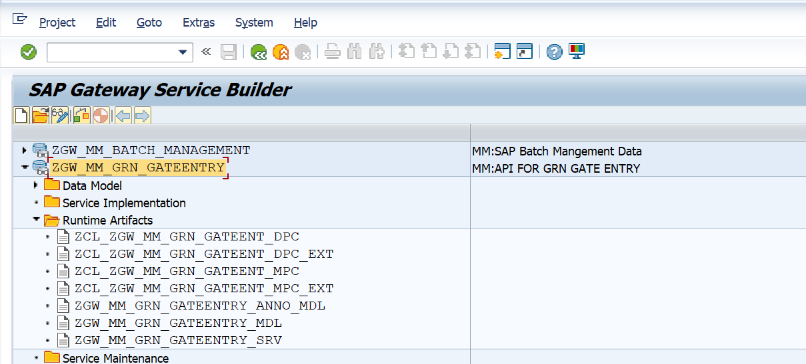

Activity-2: (Register the OData Service at DEV Gateway server)
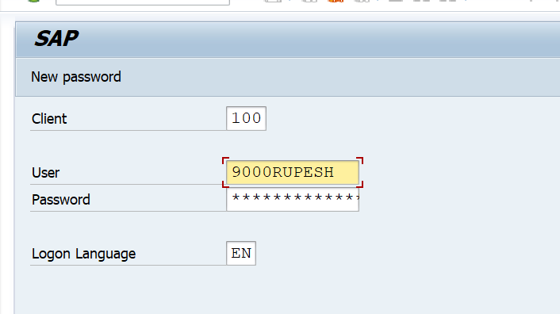
2.1: Login to the Gateway server of Development.

2.2: Go to /N/IWFND/MAINT_SERVICE TCODE.
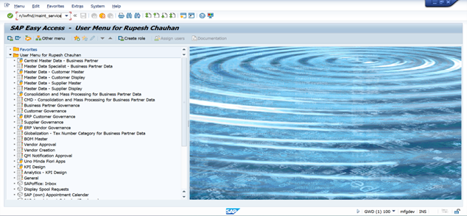
2.3: Click on “Add the service” & add the service with the Following Credential.
- System Alias: SAP_FIORI
- Technical Service Name: <OData Project Service Name>
- Click on Get services.
- Select the OData Service Name.
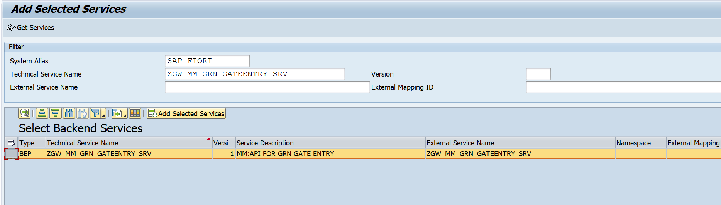
- Click on Add Selected Services.
- Pass the package Assignment as “ZMINDA_UI”.
- Enable/check the “OAuth enablement”.
- Click Continue.

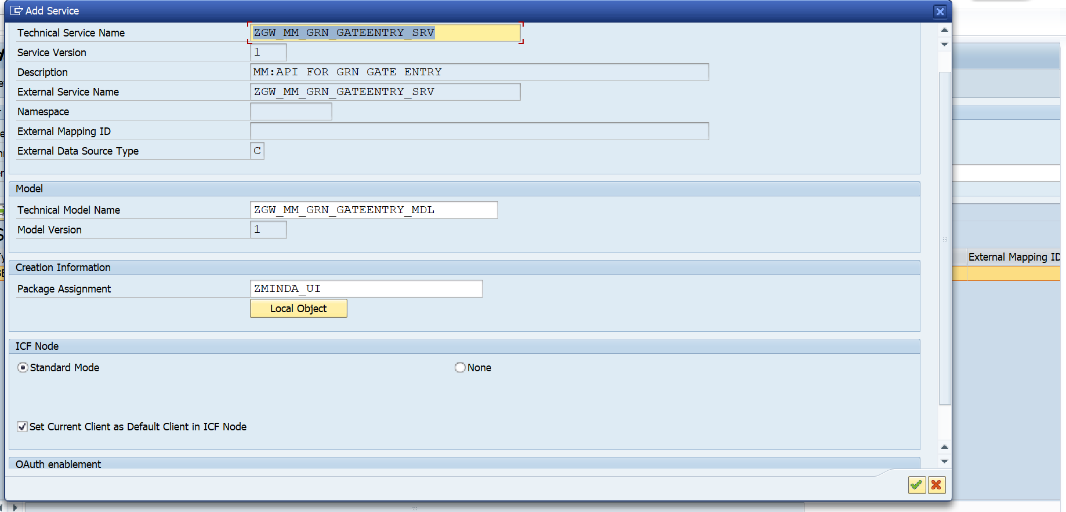
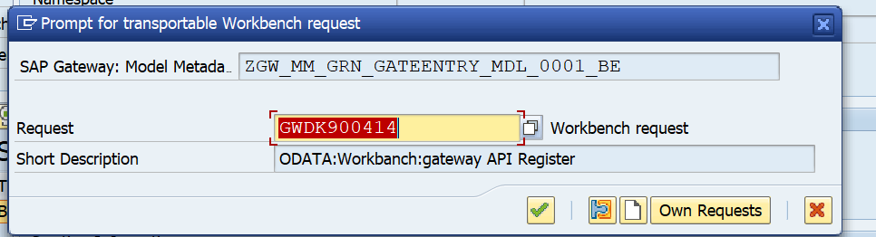
- Create a Workbench TR by clicking the Create Request Button or Pass any existing Workbench request you have and save all the remain details in the same Workbench TR.

- After saving all the details in the same TR, system will show Metadata successfully loaded message as information.

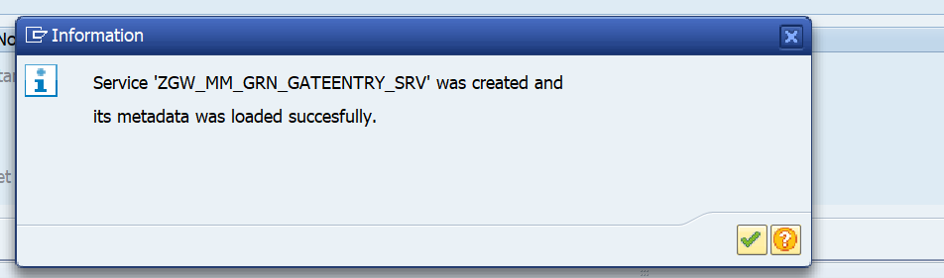
- Click on Continue.

- Return to Service and Maintain Screen or Goto /N/IWFND/MAINT_SERVICE Tcode to check whether Service successfully Registered or not.
- Pass the Service name in Filter Criteria and sear the service.
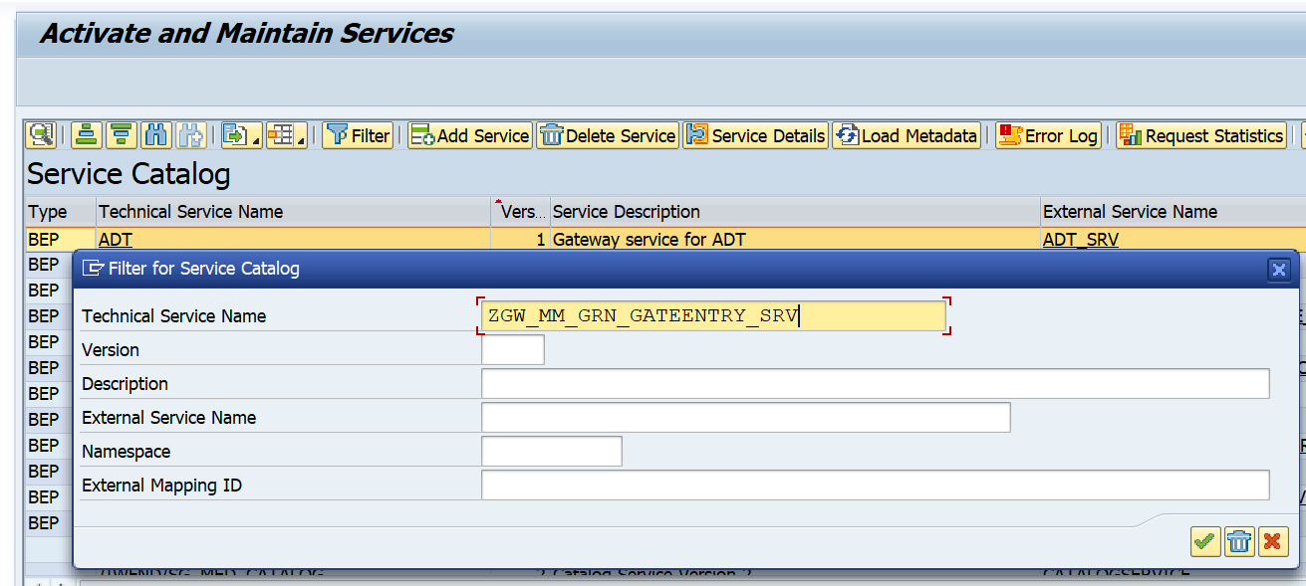

- Click on Continue.
- Yes, it’s coming means service successfully Register in Gateway.
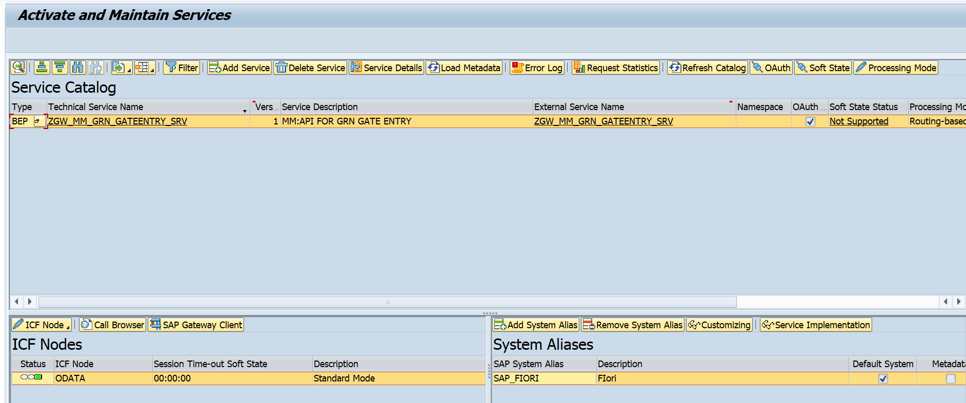

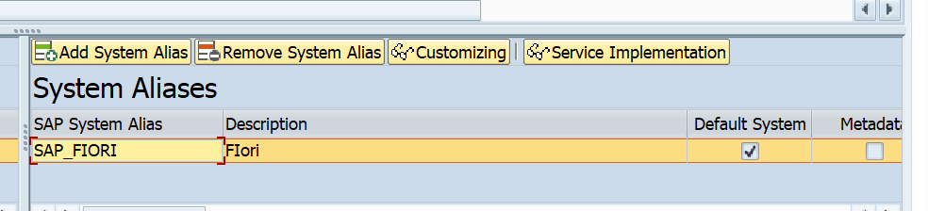
- Click the SAP System Alias value at System Aliases Section.
- Before clicking Remove System Alias Button.

- Select the Alias, Click on Remove System Alias Button.
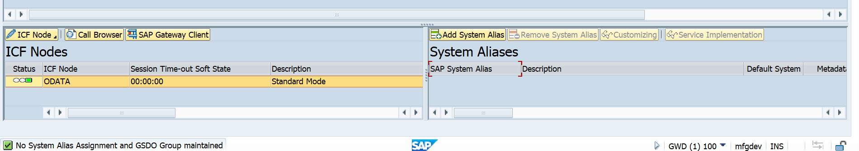
- After click on Remove System Alias Button.

- Click on Load Metadata.
- Now we have to add the system alias manually & save in a Customizing TR.
- Click the Add System Alias Button in System Alias Section.
- One below information will come, click on continue.
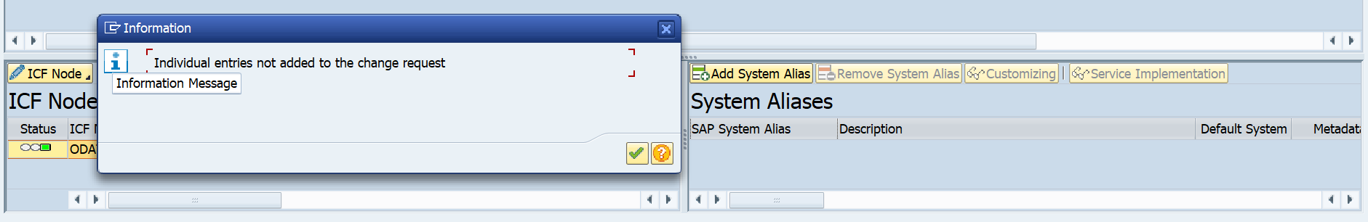

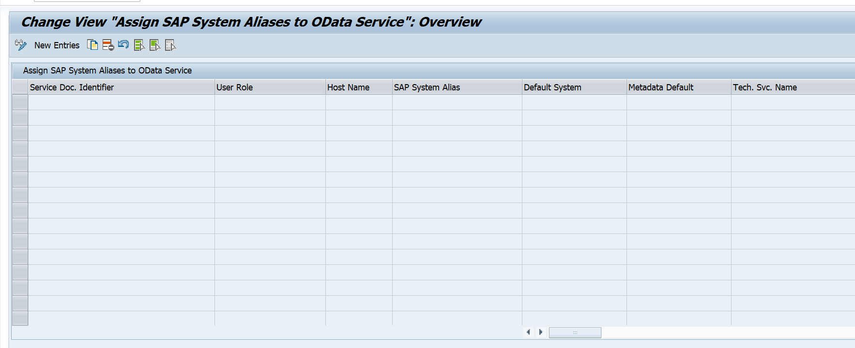
- After click on continue the below change view “Assign System Aliases to OData Services”: Overview Interface will come where we have to maintain the new alias by clicking on the New Entries Button.

- After clicking in New Entries, we have to pass the Service Doc. Identifier value.
[Click on F4 help in Service Doc. Identifier Value section CLICK ON Find Icon pass your service name along with double click on Service Document Identifier Value]
- Pass the SAP System Alias Value as SAP_FIORI.
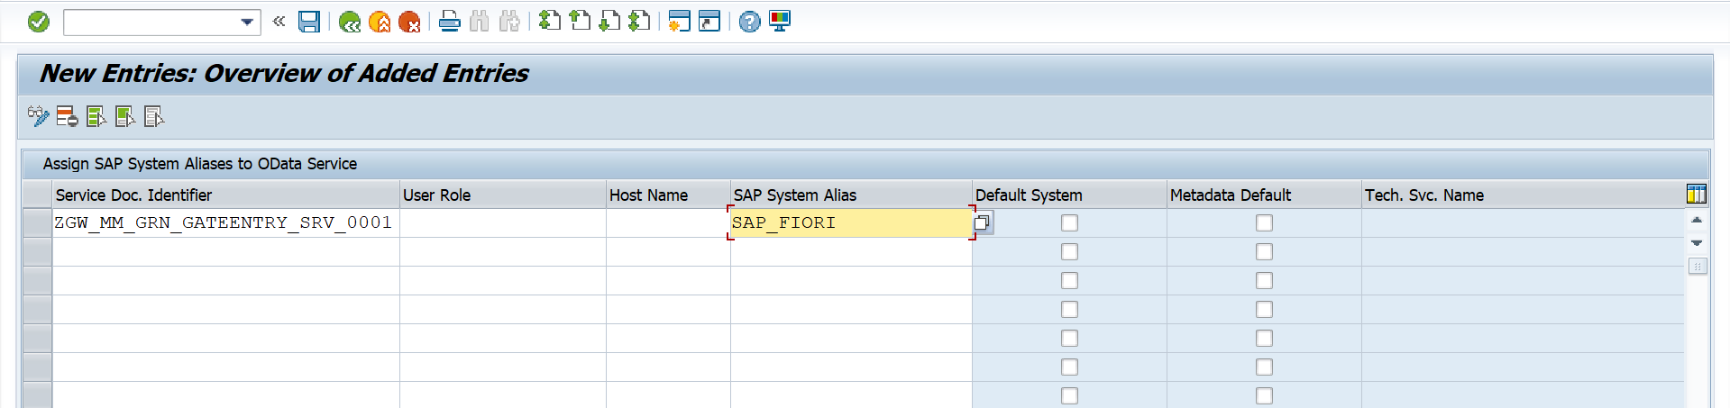
- Click on Save Button.
- System will ask a TR, here we have to pass a Customizing TR to take the Alias from one environment to another environment to Activate Purpose.
- Pass a Customizing TR/Create a Customizing TR.
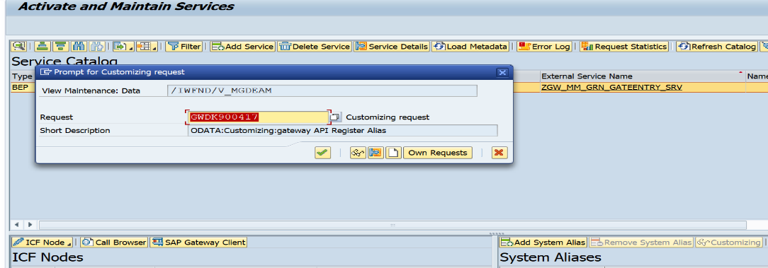

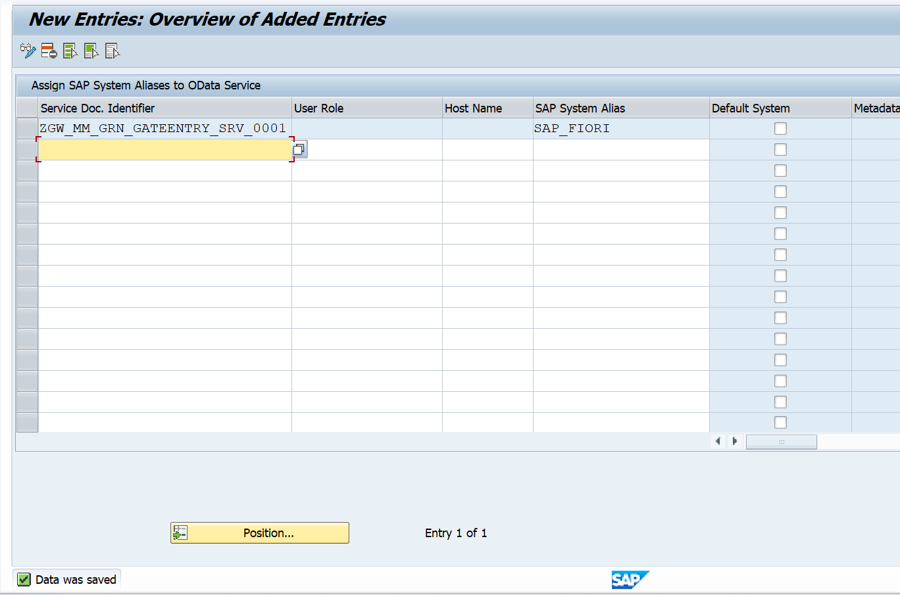
- Click on Continue and below screen will display again with a below message “Data was Saved”.

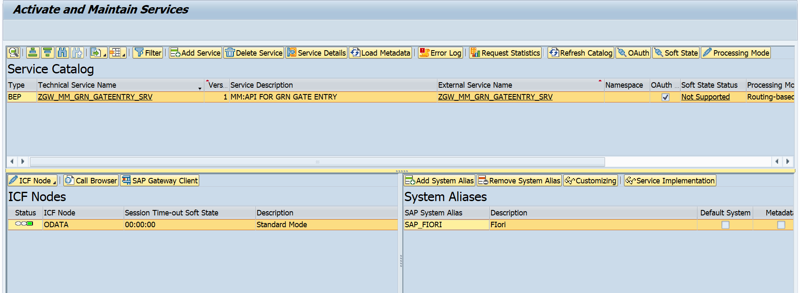
- Click on Back Button.
Now Service success fully registered in SAP Gateway server.

Activity-3: (Import the TR at Quality Server & Quality Gateway server)
Sequence of TR (Suppose move to DEV -> QAS):
Step 1: Move Workbench TR-1: contain the development object at Minda server.
After successfully imported at QAS server.
Step 2: Move Workbench TR-2: contain the details of Development Gateway-server level & import it successfully at Gateway-Quality server.
Step 3: Move the Customizing TR: Contain The system alias Detail & Import it successfully at Gateway-Quality server.

Note: Before moving this Two TR from one environment to another environment, first move the development object at Minda server to Corresponding Quality or Production Server, else it will throw Error.
Why we are removing the System Alias after successfully load the metadata at Development Gateway and add the System alias manually by following the above steps?
Answer:
if you move this Workbench TR to Gateway-Quality server & Production-Gateway, this single Workbench TR is not enough to Register and Activate the Node at Quality-Gateway & Production-Gateway server level.( Means , for the first time when you move the Workbench TR to Quality, it will resister the Service in Quality-gateway & Production-Gateway but When you check the System Alias Section, it will be inactive).
so, in order to overcome this standard bug of SAP, we have to remove the System Alias by Clicking the “Remove the system Alias“ Button in System Alias Section and Add the system Alias manually by Clicking on the “Add System Alias” button in system alias section and save it in a “Customizing TR” by Following the above steps as Shown in the Step 2.
By the combination of these Two TR(First Workbench ,second Customizing), we can successfully Register the Service in Quality-Gateway server & Production Gateway Server.
Note:
When you move the Workbench TR & import in Quality, you can check the System alias section is Inactive in the below Image.
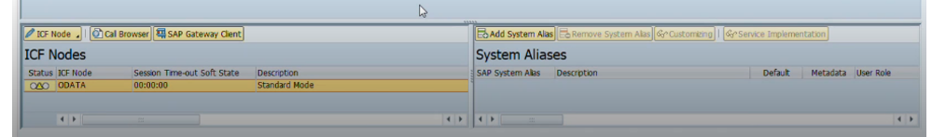
Then when you move the Customizing Tr, that section will look like the Below image.
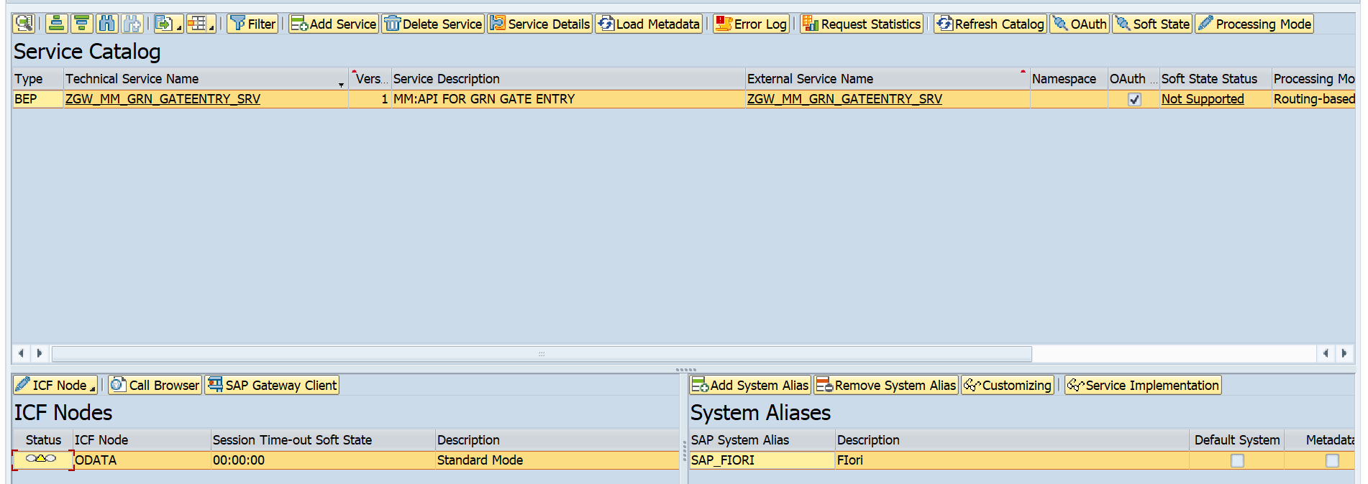

- Here you can check the Status of ICF Node is “Inactive” at in Quality Gateway.
- So, we need to activate the ICF Node, so for that we have to manually activate the ICF Node in Quality Gateway. Please follow the Below Activity.

Activity-4: (Activate the ICF Node at Quality Gateway)
After successfully move the TR to Quality, we have to manually Activate the ICF Node in Quality gateway server.
Follow the below Steps.
Step 1: Login to Quality Gateway server.
Step 2: Goto /N/IWFND/MAINT_SERVICE Tcode.
Step 3: in the Activate & maintain screen click on Filter icon & find the service.
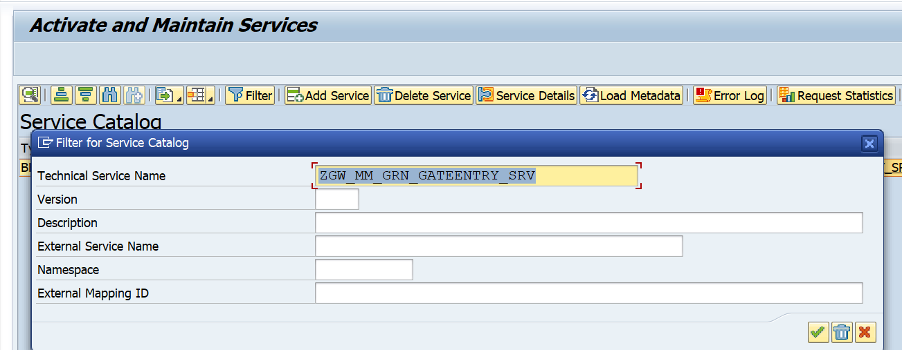
Click on continue.
Step 4: Check the Status under ICF Node. If it is inactive(Status color yellow means Inactive), then make it Active.
Inactive Status Screen. 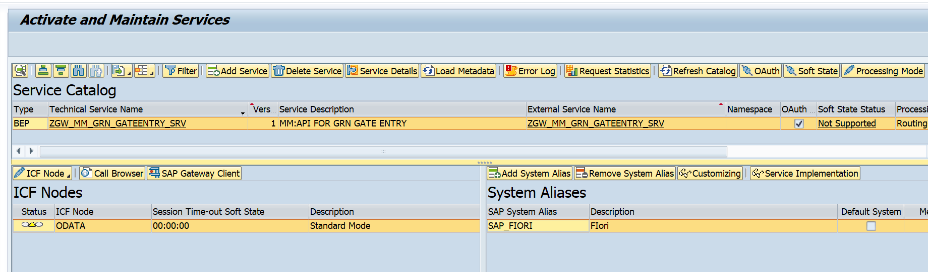
Click on Manage ICF Node icon & click on Activate.
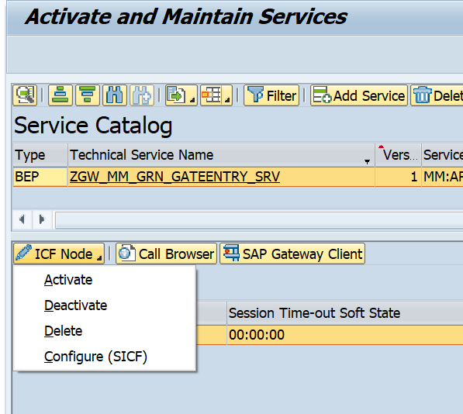
After clicking on ACTIVATE button, the status became Active from inactive (Yellow to Green).
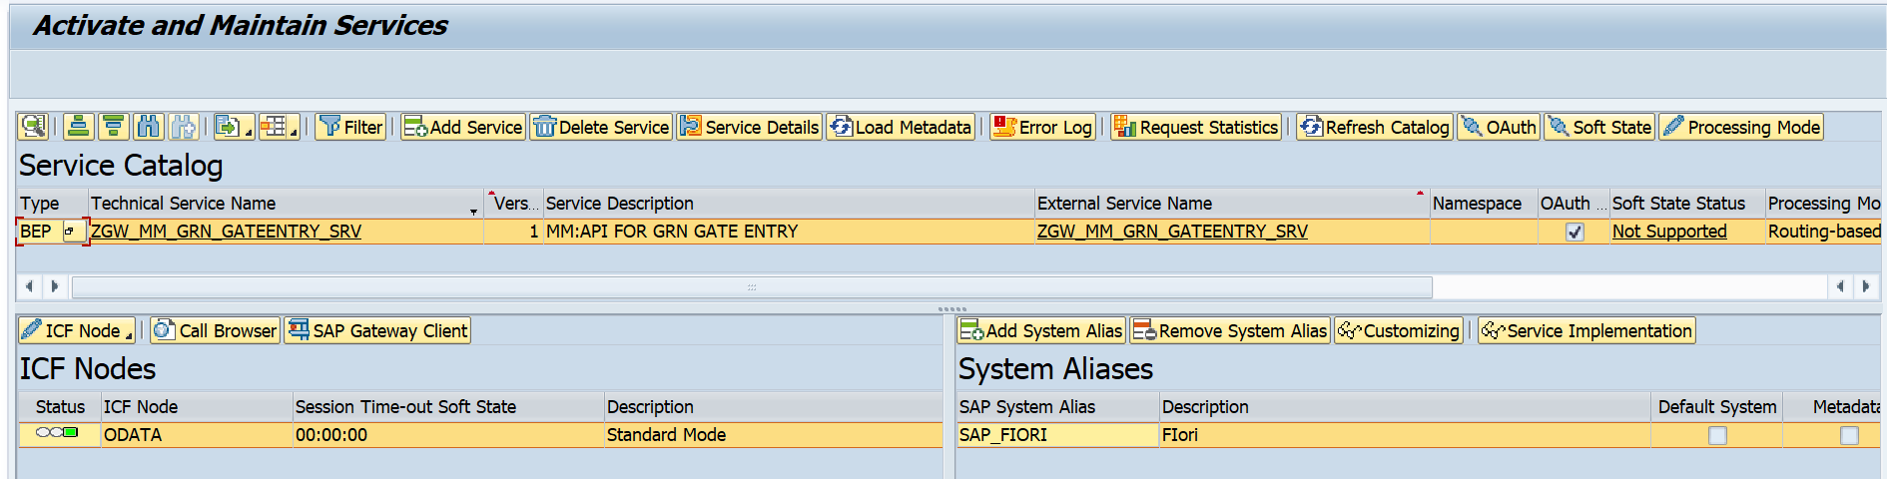
Checking The status at Gateway server of Quality.
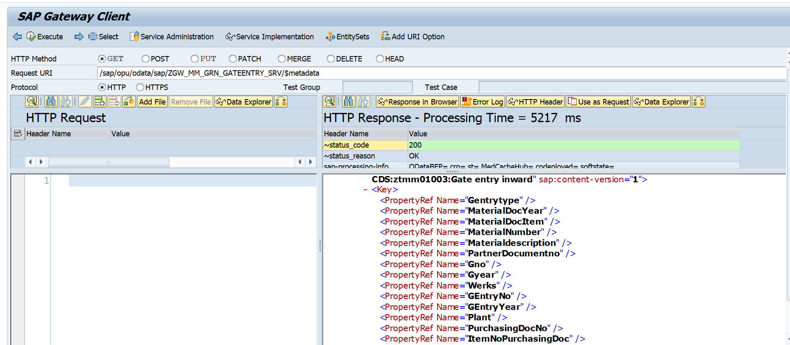

Note
By following These Steps you can successfully move the TR from Development Gateway server to Quality Gateway server and Activate the Service.

